Web Project

Mysql Instruction

1. Download Mysql
2. Look on the dump folder, it will have 3 files inside.
3. Go to Mysql -> Create a DB call it students (must named it like I wrote - students)

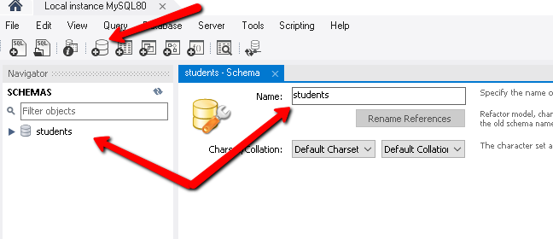

1. Import the dump (There is only 3 Tables & 2 Procedures) to import.
2. 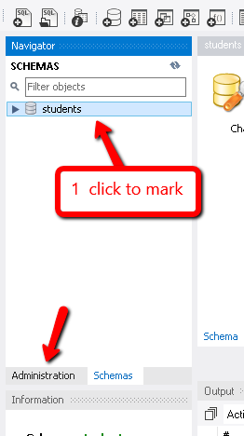Start with the 3 files (click on the DB to mark it and then go to   
   “Administration” section.
3. In “Administration” click on the “Data Import/Restore” section
4. In “Import from Disk” tab, check the “Import from Dump Project Folder” checkbox
5. Choose the Dump folder that you want to import, make sure that in “select database objects to import” there are only 3 files and not 4  
   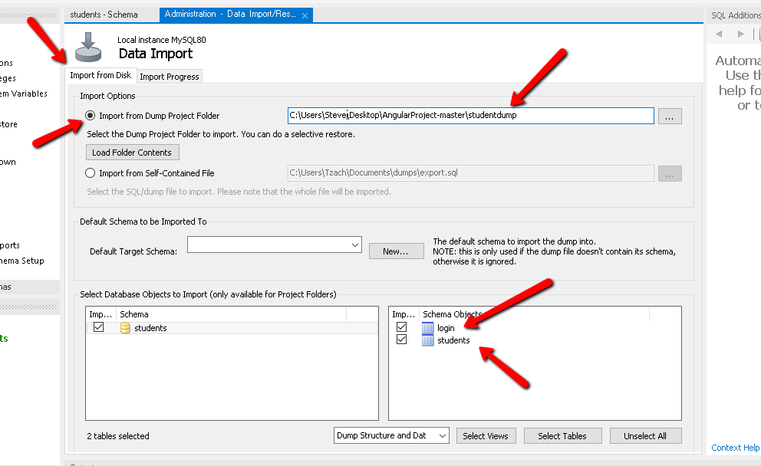
6. After that click on the “Import Progress” tab & click on the “Start Import” button

After that make sure that you have 3 tables in students DB.

1. In order to Import the “Procedures file” go to “students” DB.
2. Make one click on the “Stored Procedures” than go to “Administration” tab.
3. In “Administration” tab click on the “Import from Self-Contained File” checkbox.
4. Choose the “students_routines” Dump file.
5. In “Default Target Schema” section, choose the “students” DB  
   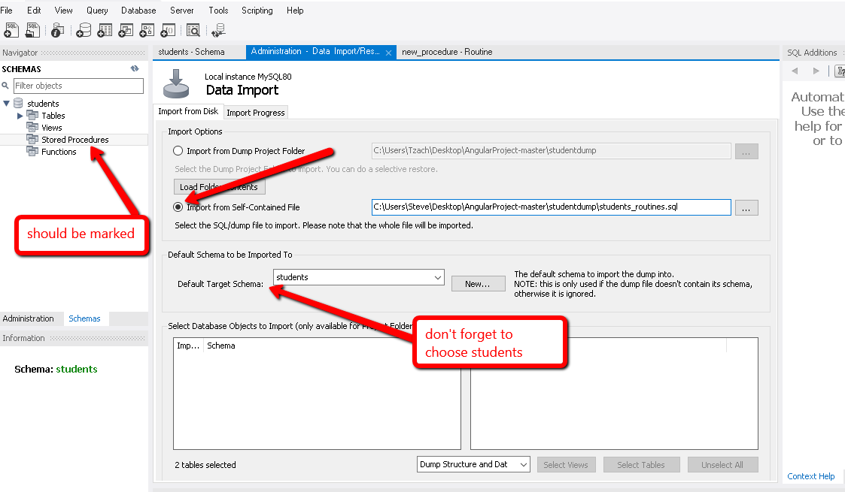

11. Click on the “Import Progress” tab & Click on the “Import” button

12. After finish import, In the DB execute this query:

use students;

ALTER USER 'root'@'localhost' IDENTIFIED WITH mysql_native_password BY 'password'; Where root as your user, localhost as your URL and password as your password

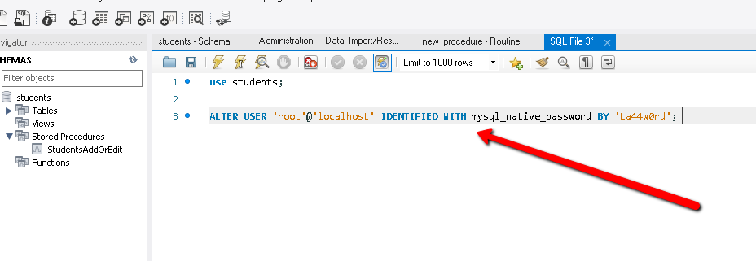

That’s it from Mysql side☺

Note – Please open the Angular and Node.js folders on 2 separated visual studio windows

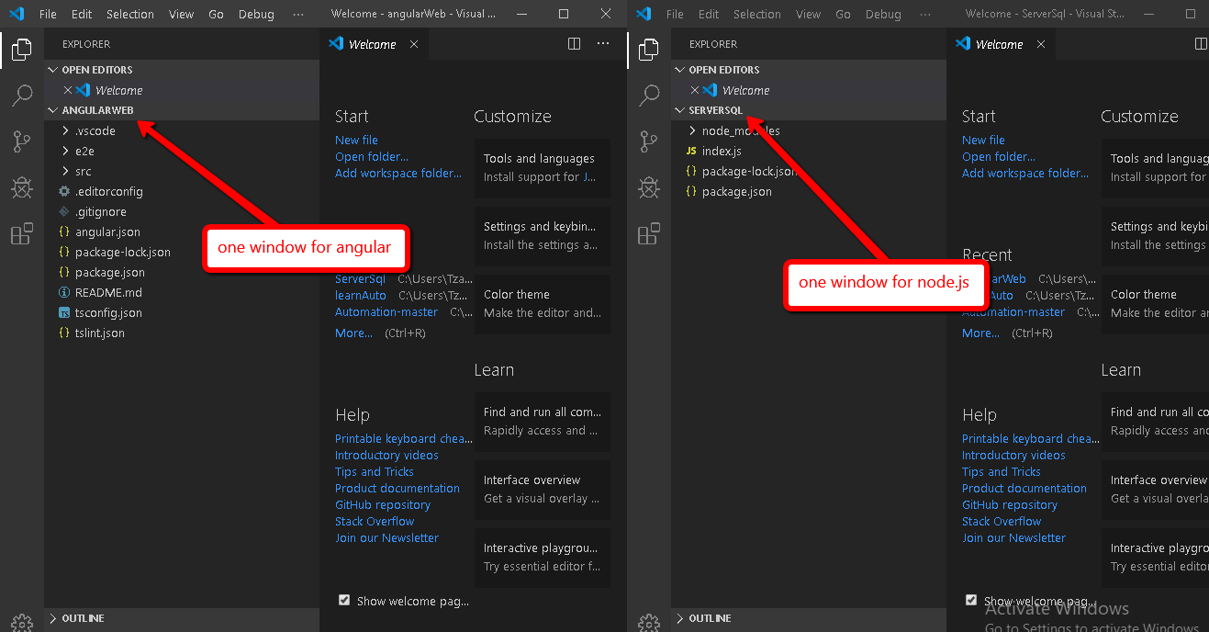

Node.JS Server steps:

1. Open visual studio code
2. Open “ServerSql” folder
3. Make sure you on the correct folder
4. Than in the “TERMINAL” execute – npm i
5. After install finished, execute – npm start
6. If everything is correct you should to see this message

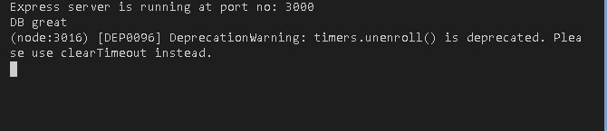

1. If not, Make sure that details are correct in the “mysqlConnection” variable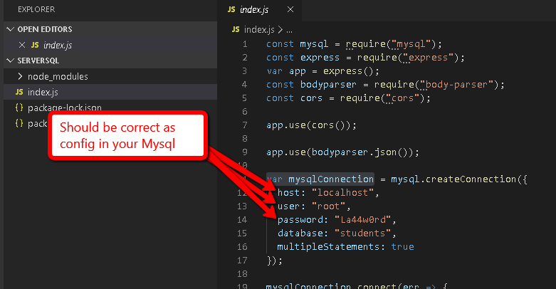

That’s it for Node.js ☺

Leave the node.js window open, for angular open a new window of visual studio code

Angular Project steps:

1. Open “angularWeb” folder
2. Make sure that your direction on the correct folder
3. Make sure that you have “Angular/cli” if not, in the “TERMINAL” execute:

npm install -g @angular/cli

1. After that execute in the “TERMINAL” “npm i” in order to install the project
2. After that in the “TERMINAL” execute “npm start”
3. If everything correct it will open automatically in the browser

That’s it for Angular☺

Generally about the project:

UserName & Password of Admin – (admin admin)

The project will have 2 login one for admin for edit student’s information, and one for students in order to see their grades.

When the admin is login, he will redirect to the “Admin Board” component, there he will be able to insert/update/delete/search student’s information, and the table will pagination after 5 students that were inserted to the students table.

Until the admin click on the “Logout” button, There is will be a “token” in admin’s “local storage” in order to remember him, and automatically to direct him (when he was login) to “Admin Board” component, when the admin will click on the “Logout” the “token” will be deleted and admin can’t never rich to “Admin Board” component, until he will login again and when he logout, he will redirect to login component.

Additionally the login for student will be his number (that the admin choose for him), When the student wants to see his grades, student will insert his number in the login for students section, and he will be able to see his information (name, grades, his number).